Features / Criteria | Business Value | Frequency of usage | No. of users | Risk
Sign up/Login
Search recipe, restaurant, chef, food lovers
Food pairing
Follow the chefs
Share preferences about restaurants with followers
Upload photos
Share articles or videos
Push notifications
Payment integration to buy recipe

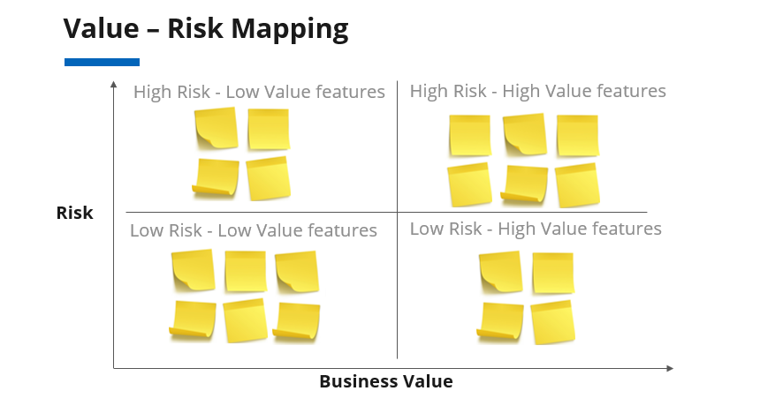

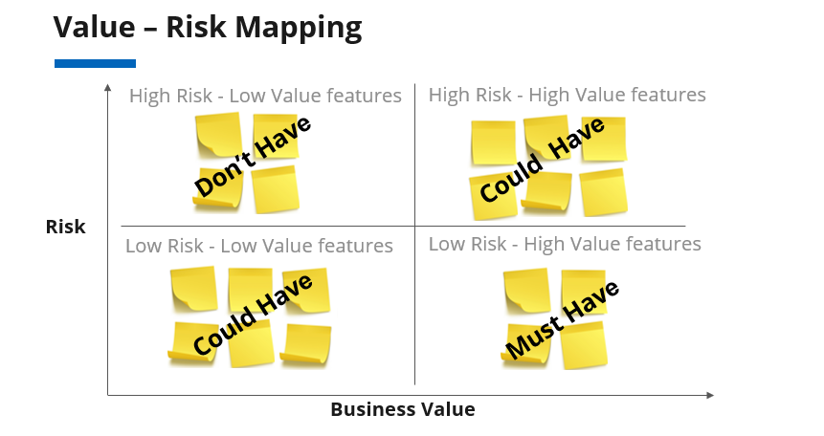

Platform/Channel | - Android/iOS/Web  - Native/Hybrid
Build Vs Buy | Use Reusable Component  - Firebase for mobile backend  - Google Apps to collect user info, Kiss metrics/mix panel for analytics  - Stripe for payment (subscription model), GoodData, Chargify, or Recurly for billing  - Live Chat for customer queries, Zendesk for customer support
Cost | - Hosting Cost  - Licensing Requirements (eg. SQL/Microsoft)  - Costs of technology framework
Build for predictable scale | Consider preliminary calculation of scalability  - Predicted number of users  - The expected rate of growth in user acquisition over x years
Development team skillset | Selecting the relevant skillset for the team  - ROR/PHP, good mobile experience
Avoid Imitation | Blindly following other’s technology decisions doesn't guarantee success

